# SUPPLIER DATABASE

WEEK - 7

Consider the following schema:

SUPPLIERS(sid: integer, sname: string, address: string)

PARTS(pid: integer, pname: string, color: string)

CATALOG(sid: integer, pid: integer, cost: real)

The Catalog relation lists the prices charged for parts by Suppliers.

Write the following queries in SQL:

i) Find the pnames of parts for which there is some supplier.

ii) Find the snames of suppliers who supply every part.

iii) Find the snames of suppliers who supply every red part.

iv) Find the pnames of parts supplied by Acme Widget Suppliers and by no one else.

v) Find the sids of suppliers who charge more for some part than the average cost of that

part (averaged over all the suppliers who supply that part).

vi) For each part, find the sname of the supplier who charges the most for that part.

Schema diagram:

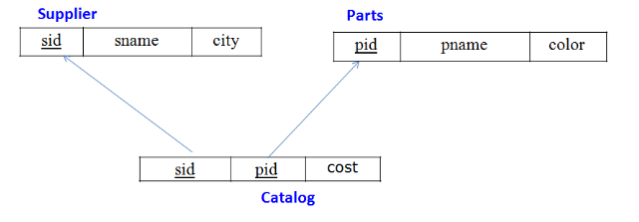

Create database

CREATE DATABASE SUPPLIER;

USE SUPPLIER;

create table

CREATE TABLE SUPPLIER( SID INT PRIMARY KEY, SNAME VARCHAR(20), CITY VARCHAR(20));

CREATE TABLE PARTS(PID INT PRIMARY KEY, PNAME VARCHAR(20), COLOR VARCHAR(20));

CREATE TABLE CATALOG( SID INT, PID INT,COST INT, FOREIGN KEY(SID) REFERENCES SUPPLIER(SID), FOREIGN KEY(PID) REFERENCES PARTS(PID));

desc SUPPLIER;

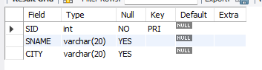

desc PARTS;

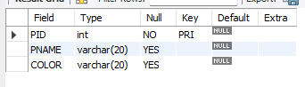

desc CATALOG;

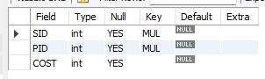

Inserting values to the table

insert into SUPPLIER values (10001, 'Acme Widget','Bangalore');

insert into SUPPLIER values (10002, 'Johns','Kolkata');

insert into SUPPLIER values (10003, 'Vimal','Mumbai');

insert into SUPPLIER values (10004, 'Reliance','Delhi');

SELECT * FROM SUPPLIER;

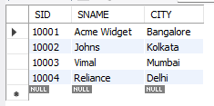

insert into PARTS values (20001, 'Book','Red');

insert into PARTS values (20002, 'Pen','Red');

insert into PARTS values (20003, 'Pencil','Green');

insert into PARTS values (20004, 'Mobile','Green');

insert into PARTS values (20005, 'Charger','Black');

SELECT * FROM PARTS ;

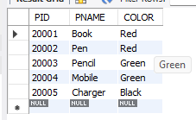

insert into CATALOG values (10001, 20001 , 10);

insert into CATALOG values (10001, 20002 , 10);

insert into CATALOG values (10001, 20003 , 30);

insert into CATALOG values (10001, 20004 , 10);

insert into CATALOG values (10001, 20005 , 10);

insert into CATALOG values (10002, 20001 , 10);

insert into CATALOG values (10002, 20002 , 20);

insert into CATALOG values (10003, 20003 , 30);

insert into CATALOG values (10004, 20003 , 40);

SELECT * FROM CATALOG;

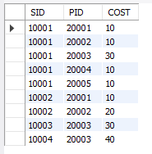

Queries

i) Find the pnames of parts for which there is some supplier.

SELECT DISTINCT P.PNAME FROM PARTS P, CATALOG C WHERE P.PID=C.PID;

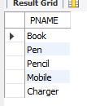

ii) Find the snames of suppliers who supply every part.

SELECT DISTINCT S.SNAME FROM CATALOG C,SUPPLIER S WHERE C.SID=S.SID

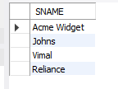

iii) Find the snames of suppliers who supply every red part.

SELECT DISTINCT S.SNAME FROM CATALOG C,SUPPLIER S WHERE C.SID=S.SID AND NOT EXISTS(SELECT P.PID

FROM PARTS P WHERE P.COLOR="Red" AND NOT EXISTS (SELECT C1.SID FROM CATALOG C1 WHERE C1.SID=C.SID AND C1.PID=P.PID AND P.COLOR="RED"));

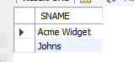

iv) Find the pnames of parts supplied by Acme Widget Suppliers and by no one else.

SELECT P.PNAME FROM PARTS P , CATALOG C,SUPPLIER S WHERE P.PID=C.PID AND C.SID=S.SID

AND S.SNAME='Acme Widget' AND NOT EXISTS (SELECT * FROM CATALOG C1,SUPPLIER S1 WHERE P.PID=C1.PID AND C1.SID=S1.SID AND S1.SNAME!="Acme Widget");

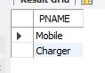

v) Find the sids of suppliers who charge more for some part than the average cost of that

part (averaged over all the suppliers who supply that part).

select distinct c.sid from catalog c where c.cost>(select avg(c1.cost) from catalog c1 where c1.pid=c.pid);

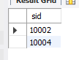

vi) For each part, find the sname of the supplier who charges the most for that part.

select p.pid,s.sname FROM PARTS P , CATALOG C,SUPPLIER S where P.PID=C.PID AND C.SID=S.SID and c.cost=(select max(c1.cost) from catalog c1 where c1.pid=p.pid);

